Glenohumeral Internal Rotation Deficit and Scapular Dyskinesia Protocol

Focus on IR and posterior capsule stretching
- Sleeper Stretch: Hold for 20-30 seconds; 3 sets of 10
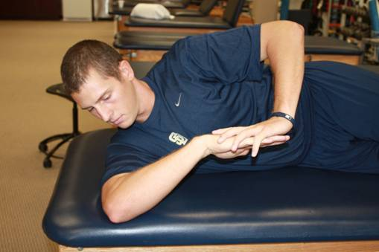

- Sidelying adduction: stretch affected shoulder into adduction using unaffected side
  - Hold for 20-30 seconds; 3 sets of 10
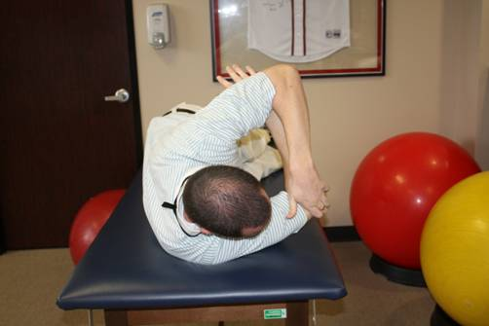

- Manual Stretching and joint mobilization
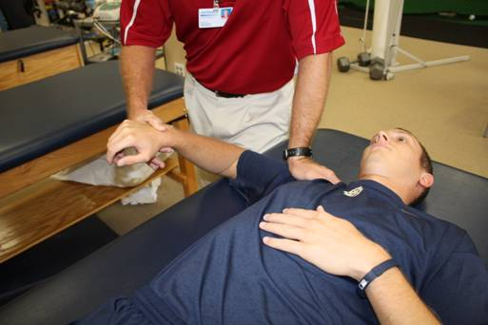

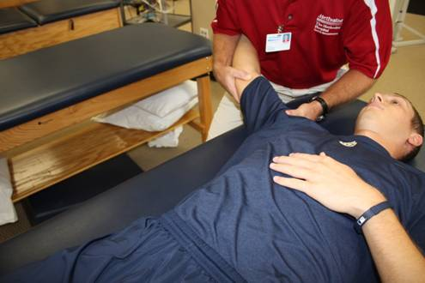

Scapular Stabilization
- Isometric scapular retraction and depression
- Scapular clock
- Shoulder shrugs
- Prone rows and seated rows
- Push-ups with a plus – wall, table, floor
- Supine scapular punches
- Lat pull downs
- Prone scaption

